Waabanong Weekly Update
Week of May 4, 2026
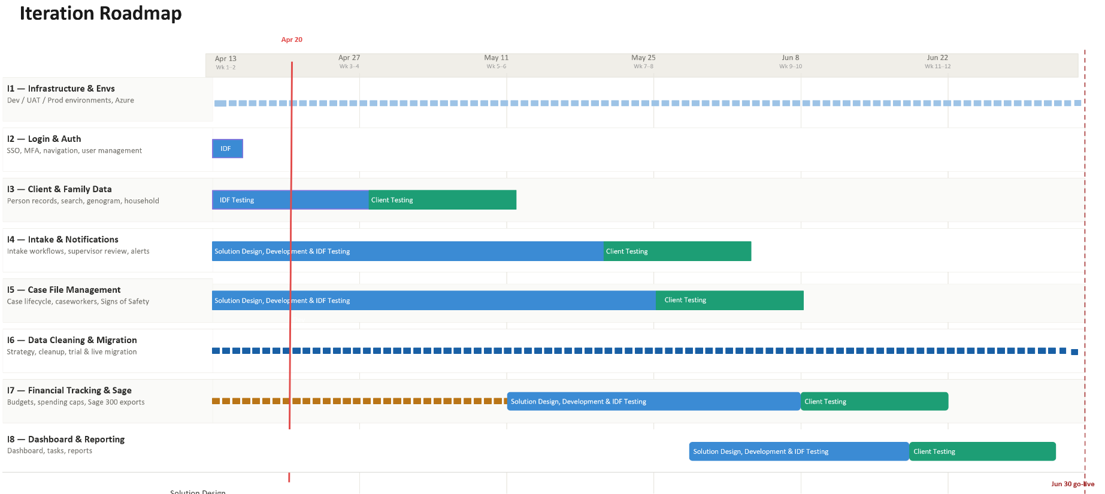

Iteration | Status | Current phase | Notes
I1 - System Infrastructure & Environments | In progress | Setting up Testing | Azure Testing environment data migration in progress
I2 - Login & Authorization | In progress | IDF Testing | Deployment for client testing pending Azure environment readiness
I3 - Client, Member & Family Data | In progress | IDF Testing | Internal IDF testing continues; minor bug-fix cycle
I4 - Intake Management & Automated Notifications | In progress | Wireframe review with client | Two intake-module wireframe walkthroughs completed with the PCFS intake team; significant design feedback captured; May 4 bug-fix batch (PR #29) shipped
I5 - Case File Management & Signs of Safety | In progress | Solution design | Intake-to-case linking model refined from intake-module sessions; Apr 29 Ongoing Service walkthrough updates in progress
I6 - Data Migration | In progress | Planning | Working with Campfire to determine how to access data and maintain privacy/security
I7 - Financial Tracking & Exports for Sage | In progress | Solution design | Advanced wireframes for PO and credit-card reconciliation in progress; next finance working session pending
I8 - My Dashboard & Reporting | Not started

Project Management & General
Weekly Progress
- Intake module wireframe review with the PCFS intake team — two working sessions completed (Tue morning, 2 hours total) with Ross, Darryl, Kelvin and others; detailed walkthrough of the full intake form, persons-involved, intake log, eligibility, escalation, prior-contact check, and print views.
- Substantive design feedback captured (see I4 for detail); decisions taken on document categorization, issue-category list expansion, supervisor override scope, multi-intake handling, intake-to-case linking, and CSIS handoff.
- Recurring cadence confirmed — weekly Tuesday working sessions; next overall review with Clemen scheduled for the following Tuesday afternoon.
- Development continued — May 4 bug-fix batch (PR #29) merged covering task-module refactors, eligibility banner messaging, intake print toolbar, and form responsiveness.
- One additional Tuesday afternoon session (1:09 pm) was recorded but has no transcript yet — content not integrated into this report.

I1 - System Infrastructure & Environments
Features
- Set up Development, Testing, and Production environments
Weekly Progress
- No new updates this week.
I2 - Login & Authorization
Features
- Microsoft 365–based authentication
- User login
Weekly Progress
- No new updates this week.
I3 - Client, Member & Family Data
Features
- Centralized person records (children, adults, limited profiles)
  - Duplicate prevention
- Family and household structures
  - Multi-generation relationships
- Reciprocal relationship logic
- Global search across people and families
Weekly Progress
- No new external feedback this week — internal IDF testing continues.
- Person-record edits from inside the intake form confirmed during the intake walkthrough (address updates flow back to the person record, with full change log).

I4 - Intake Management & Automated Notifications
Features
- Structured intake workflows with mandatory fields
- Intake status tracking and lifecycle
- Supervisor review and approval processes
- Ability to resolve intake without opening a case
- Escalation from intake to case creation
- Printable intake records
- Automated notifications:
  - In-application alerts
  - Defined external channels (email/messaging)
Weekly Progress
- Two intake-module wireframe walkthroughs completed with the PCFS intake team (Tue morning sessions).
  - Header & banner — persistent banner confirmed; intake unique ID with linkable CFSIS ID; risk-category badges plus countdown timer per the issue’s mandated response time.
  - Document upload — multi-file upload accepted; separate document name vs. file name; document-type list to be defined (legal, photo, receipt, other, etc.) — Peguis to share a current working list; executable file types excluded; HEIC/TIFF/PNG support for mobile uploads.
  - Browser preference — Microsoft Edge confirmed as primary target browser.
  - Auto-save — Save and Continue model retained for now; if the session times out, current entries are preserved; UAT will inform whether explicit autosave is needed.
  - Referral source — always confidential by policy; will appear on the form but not in the persons-involved list; possible future enhancement to link a referral source back to a person record (supervisor/director-managed correction permission).
  - Persons involved — search-driven add; "add limited profile" option when person is not yet in the system; add-from-genogram for fast linking of family members; inline edit of the linked person record from the intake form (with change log); icon to be changed to a pencil/edit icon (not new-window).
  - Issue categories — keep grid layout (multi-select); expand to full Manitoba IM list with sub-categories and "other" as a real category with criteria; each category drives a mandated response timer; presentation alphabetical; sub-categories likely as checkboxes inside a modal triggered from the category tile.
  - Recommended response time — auto-filled from category/sub-category, no override field (override field removed from form per worker discussion).
  - Actions taken — keep the layout as it appears on the paper form (preserve familiar order).
  - Eligibility — move the eligibility-check screen down into the supervisor section; worker may still proceed with intake by entering an override reason (used during after-hours emergencies for non-Peguis families).
  - Multiple intakes — same person may have multiple open intakes (e.g., after-hours plus daytime); on starting a new intake for a person with an existing open intake, show a prompt offering to continue the open one OR start a new one.
  - Intake-to-case linking — when an intake is escalated to a case, retain the link between intake ID and case ID (and any subsequent intakes on the same case) so that history is traceable.
  - Send-back-for-more-info — supervisor can return an intake to the worker with a due date; the original response-time timer keeps running in the background regardless of the rework window.
  - Approval flow — worker submits, supervisor reviews, then Chief Operating Officer (Kelvin) approves escalation to a case; assignment to ongoing-services team follows after that.
  - Prior contact check — required before CSIS entry; lives in the supervisor section; gate to "Concluded" status.
  - Intake log — immutable, reverse-chronological cards of all actions on the intake (create, edits, additions/removals of people, notes, document uploads, status changes); prior intakes and case history for the same person also surface here as linkable items.
  - Print — both filled and blank intake forms; sensitive data not redacted (workers need full record in the field, including dead-zone scenarios).
  - Status values — Open or Concluded only (no intermediate "pending" state for the final outcome).
  - Smart-quote / character-encoding issue when copy-pasting from intake into CSIS captured on the roadmap for a future quality-of-life fix.
- May 4 bug-fix batch (PR #29) shipped to master.
  - Task module — linked-records refactor: sync linked row from form, default linked ID, Person added to linked-record options, normalized request handling, improved display formatting; past-due dates no longer permitted on task creation; task filtering moved to database-backed codes.
  - Intake eligibility — IntakeEligibilityService extracted from controller; eligibility banner rendering streamlined; banner messaging refined based on caregiver name and reason.
  - Print and UI — print icon SVG added; persistent header print button; sticky toolbar image rendering adjusted; task-form styling with min-width constraints and improved overflow handling.
  - Modals — blur effect on active element before opening modal in tasks view.
I5 - Case File Management & Signs of Safety
Features
- Case file creation and lifecycle management
- Assignment of caseworkers and supervisors
- Case reassignment with approval
- Signs of Safety–aligned workflows, including:
  - Placement
  - Structured assessments
  - Safety goals and planning
  - Ongoing review checkpoints
- Visibility into historical and related cases
- Case notes for visits, services, and interactions
- Communication tracking across intake and case contexts
  - Document management: Person, Intake & Case
Weekly Progress
- Intake-to-case linking model refined during the intake walkthroughs — confirmed need to preserve a chain of intake IDs → case ID, including any follow-on intakes opened against the same case, so case history remains traceable.
- Director-level (COO) approval step confirmed in the escalation flow (worker → supervisor → director → case opened and assigned).
- Apr 29 Ongoing Service walkthrough design updates continue offline (Director field on case record, team-admin screen, persons-in-case enhancements, conflict-of-interest under safety/confidentiality, role-based dashboards).
- Wireframes & Solution Design are in progress
- Preliminary wireframes covering case record type, case notes, and placement require review with Ongoing Service Team. Marcus to reach out to Ross to schedule.
I6 - Data Cleaning and Migration
Features
- Develop a data migration strategy from FAMCare into Waabanong
- Support PCFS as they perform data cleanup
- Execute trial data migrations in a sandbox environment
- Perform live data migration
Weekly Progress
- No new updates this week.
I7 - Financial Tracking & Exports for Sage
Features (Potential scope may include)
- Intake-level emergency supports
- Case-level budgets
- Spending caps and approvals
- Export files to import into Sage 300
Weekly Progress
- No new external sessions this week — advanced wireframes for PO and credit-card reconciliation continue offline ahead of the next finance working session.
I8 - My Dashboard & Reporting
Features (Potential scope may include)
- My Dashboard (simple, quick reference to key items)
- Tasks & alerts
- Reporting (if required and not covered in other iterations)
Weekly Progress
- Future iteration per schedule (nothing this week).

